Software Quality Assurance Project Proposal

Student name: Hafiz Muhammad Adnan Nawaz

Testing website: <https://www.alibaba.com/>

Demo of website:

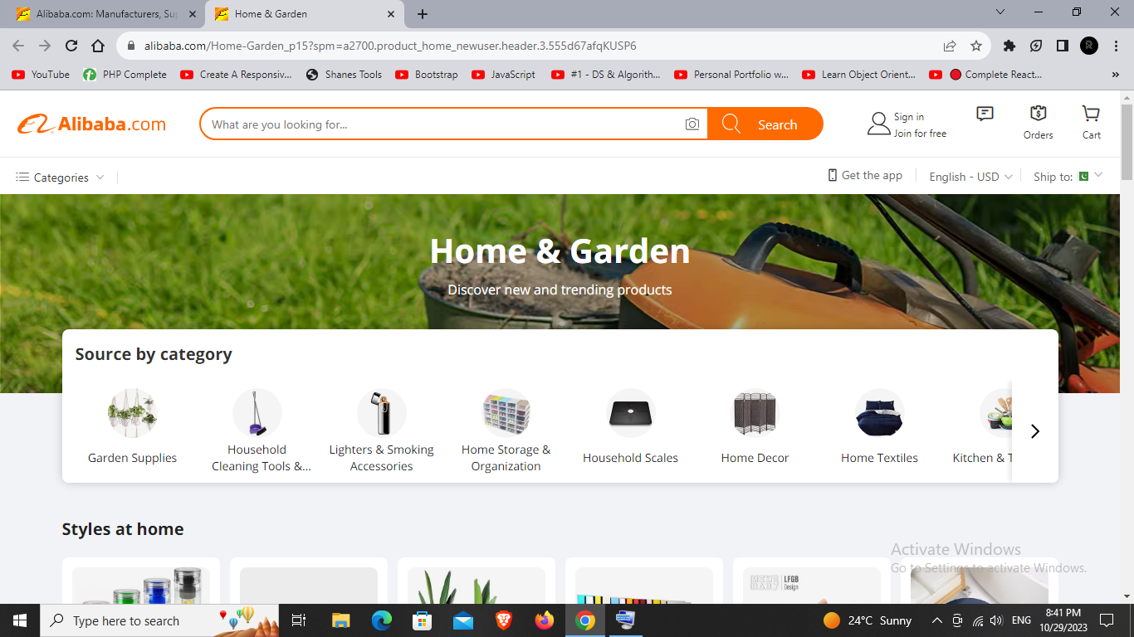

Summary:

Alibaba.com serves as a comprehensive platform with the primary purpose of facilitating global trade, connecting businesses, and empowering them with the tools and resources needed to thrive in the modern digital marketplace. It plays a pivotal role in the globalization of commerce, helping businesses of all sizes expand their horizons and reach a broader audience.

Objective:

To ensure that users can successfully create accounts and log in to the website.

To ensure that users can search for products and browse listings effectively.

To ensure a seamless shopping and checkout process.

This is a basic outline I will check the different modules of the site through different testing techniques e.g. functional, non-functional and through performance testing techniques.